Finance
We have to work with money every day. While balancing your checkbook or calculating your monthly expenditures on espresso requires only arithmetic, when we start saving, planning for retirement, or need a loan, we need more mathematics.

Simple Interest
Discussing interest starts with the principal, or amount your account starts with. This could be a starting investment, or the starting amount of a loan. Interest, in its most simple form, is calculated as a percent of the principal. For example, if you borrowed $100 from a friend and agree to repay it with 5% interest, then the amount of interest you would pay would just be 5% of 100: $100(0.05) = $5. The total amount you would repay would be $105, the original principal plus the interest.

Simple One-time Interest
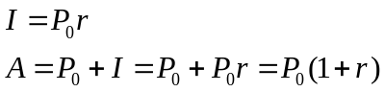

I is the interest
A is the end amount: principal plus interest
P₀ is the principal (starting amount)
r is the interest rate (in decimal form. Example: 5% = 0.05)

Example 1
A friend asks to borrow $300 and agrees to repay it in 30 days with 3% interest. How much interest will you earn?

P₀ = $300 the principal
r = 0.03 3% rate
I = $300(0.03) = $9. You will earn $9 interest.

One-time simple interest is only common for extremely short-term loans. For longer term loans, it is common for interest to be paid on a daily, monthly, quarterly, or annual basis. In that case, interest would be earned regularly. For example, bonds are essentially a loan made to the bond issuer (a company or government) by you, the bond holder. In return for the loan, the issuer agrees to pay interest, often annually. Bonds have a maturity date, at which time the issuer pays back the original bond value.

Example 2
Suppose your city is building a new park, and issues bonds to raise the money to build it. You obtain a $1,000 bond that pays 5% interest annually that matures in 5 years. How much interest will you earn?
Each year, you would earn 5% interest: $1000(0.05) = $50 in interest. So over the course of five years, you would earn a total of $250 in interest. When the bond matures, you would receive back the $1,000 you originally paid, leaving you with a total of $1,250.

We can generalize this idea of simple interest over time.

Simple Interest over Time
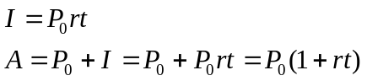

I is the interest
A is the end amount: principal plus interest
P₀ is the principal (starting amount)
r is the interest rate in decimal form
t is time

The units of measurement (years, months, etc.) for the time should match the time period for the interest rate.

APR – Annual Percentage Rate
Interest rates are usually given as an annual percentage rate (APR) – the total interest that will be paid in the year. If the interest is paid in smaller time increments, the APR will be divided up.

For example, a 6% APR paid monthly would be divided into twelve 0.5% payments.
A 4% annual rate paid quarterly would be divided into four 1% payments.

Example 3
Treasury Notes (T-notes) are bonds issued by the federal government to cover its expenses. Suppose you obtain a $1,000 T-note with a 4% annual rate, paid semi-annually, with a maturity in 4 years. How much interest will you earn?

Since interest is being paid semi-annually (twice a year), the 4% interest will be divided into two 2% payments.

P₀ = $1000 the principal
r = 0.02 2% rate per half-year
t = 8 4 years = 8 half-years
I = $1000(0.02)(8) = $160. You will earn $160 interest total over the four years.

Try it Now 1
A loan company charges $30 interest for a one month loan of $500. Find the annual interest rate they are charging.

Compound Interest
With simple interest, we were assuming that we pocketed the interest when we received it. In a standard bank account, any interest we earn is automatically added to our balance, and we earn interest on that interest in future years. This reinvestment of interest is called compounding.

Suppose that we deposit $1000 in a bank account offering 3% interest, compounded monthly. How will our money grow?

The 3% interest is an annual percentage rate (APR) – the total interest to be paid during the year. Since interest is being paid monthly, each month, we will earn 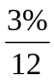= 0.25% per month.

In the first month,
P₀ = $1000
r = 0.0025 (0.25%)
I = $1000 (0.0025) = $2.50
A = $1000 + $2.50 = $1002.50

In the first month, we will earn $2.50 in interest, raising our account balance to $1002.50.
In the second month,

P₀ = $1002.50
I = $1002.50 (0.0025) = $2.51 (rounded)
A = $1002.50 + $2.51 = $1005.01

Notice that in the second month we earned more interest than we did in the first month. This is because we earned interest not only on the original $1000 we deposited, but we also earned interest on the $2.50 of interest we earned the first month. This is the key advantage that compounding of interest gives us.

Calculating out a few more months:
Month | Starting balance | Interest earned | Ending Balance
1 | 1000.00 | 2.50 | 1002.50
2 | 1002.50 | 2.51 | 1005.01
3 | 1005.01 | 2.51 | 1007.52
4 | 1007.52 | 2.52 | 1010.04
5 | 1010.04 | 2.53 | 1012.57
6 | 1012.57 | 2.53 | 1015.10
7 | 1015.10 | 2.54 | 1017.64
8 | 1017.64 | 2.54 | 1020.18
9 | 1020.18 | 2.55 | 1022.73
10 | 1022.73 | 2.56 | 1025.29
11 | 1025.29 | 2.56 | 1027.85
12 | 1027.85 | 2.57 | 1030.42

To find an equation to represent this, if P_{m} represents the amount of money after m months, then we could write the recursive equation:

P₀ = $1000
P_{m} = (1+0.0025)P_{m-1}

You probably recognize this as the recursive form of exponential growth. If not, we could go through the steps to build an explicit equation for the growth:
P₀ = $1000
P₁ = 1.0025P₀ = 1.0025 (1000)
P₂ = 1.0025P₁ = 1.0025 (1.0025 (1000)) = 1.0025 ²(1000)
P₃ = 1.0025P₂ = 1.0025 (1.0025²(1000)) = 1.0025³(1000)
P₄ = 1.0025P₃ = 1.0025 (1.0025³(1000)) = 1.0025⁴(1000)

Observing a pattern, we could conclude

P_{m} = (1.0025)^{m}($1000)

Notice that the $1000 in the equation was P₀, the starting amount. We found 1.0025 by adding one to the growth rate divided by 12, since we were compounding 12 times per year.
Generalizing our result, we could write
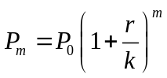
In this formula:
m is the number of compounding periods (months in our example)
r is the annual interest rate
k is the number of compounds per year.

While this formula works fine, it is more common to use a formula that involves the number of years, rather than the number of compounding periods. If N is the number of years, then m = N k. Making this change gives us the standard formula for compound interest.

Compound Interest
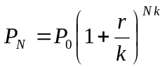

P_{N} is the balance in the account after N years.
P₀ is the starting balance of the account (also called initial deposit, or principal)
r is the annual interest rate in decimal form
k is the number of compounding periods in one year.

If the compounding is done annually (once a year), k = 1.
If the compounding is done quarterly, k = 4.
If the compounding is done monthly, k = 12.
If the compounding is done daily, k = 365.
The most important thing to remember about using this formula is that it assumes that we put money in the account once and let it sit there earning interest.

Example 4
A certificate of deposit (CD) is a savings instrument that many banks offer. It usually gives a higher interest rate, but you cannot access your investment for a specified length of time. Suppose you deposit $3000 in a CD paying 6% interest, compounded monthly. How much will you have in the account after 20 years?

In this example,
P₀ = $3000 the initial deposit
r = 0.06 6% annual rate
k = 12 12 months in 1 year
N = 20 since we’re looking for how much we’ll have after 20 years

So 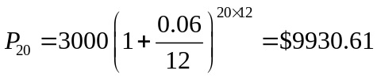 (round your answer to the nearest penny)

Let us compare the amount of money earned from compounding against the amount you would earn from simple interest
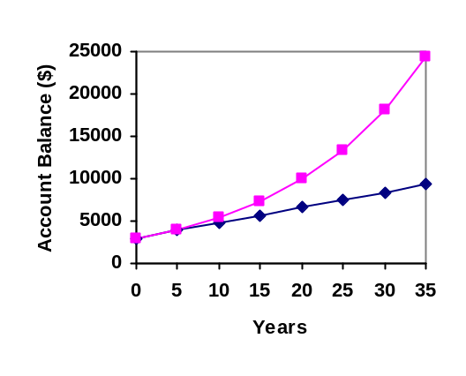
Years | Simple Interest ($15 per month) | 6% compounded monthly = 0.5% each month.
5 | $3900 | $4046.55
10 | $4800 | $5458.19
15 | $5700 | $7362.28
20 | $6600 | $9930.61
25 | $7500 | $13394.91
30 | $8400 | $18067.73
35 | $9300 | $24370.65

As you can see, over a long period of time, compounding makes a large difference in the account balance. You may recognize this as the difference between linear growth and exponential growth.

Evaluating exponents on the calculator
When we need to calculate something like 5³ it is easy enough to just multiply 5⋅5⋅5=125. But when we need to calculate something like 1.005²⁴⁰ , it would be very tedious to calculate this by multiplying 1.005 by itself 240 times! So to make things easier, we can harness the power of our scientific calculators.

Most scientific calculators have a button for exponents. It is typically either labeled like:

^ , y^{x} , or x^{y} .

To evaluate 1.005²⁴⁰ we'd type 1.005 ^ 240, or 1.005 y^{x} 240. Try it out - you should get something around 3.3102044758.

Example 5
You know that you will need $40,000 for your child’s education in 18 years. If your account earns 4% compounded quarterly, how much would you need to deposit now to reach your goal?

In this example,
We’re looking for P_{0.}
r = 0.04 4%
k = 4 4 quarters in 1 year
N = 18 Since we know the balance in 18 years
P₁₈ = $40,000 The amount we have in 18 years

In this case, we’re going to have to set up the equation, and solve for P₀.
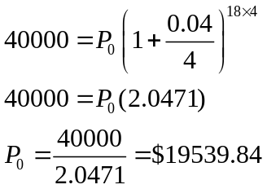

So you would need to deposit $19,539.84 now to have $40,000 in 18 years.

Rounding
It is important to be very careful about rounding when calculating things with exponents. In general, you want to keep as many decimals during calculations as you can. Be sure to keep at least 3 significant digits (numbers after any leading zeros). Rounding 0.00012345 to 0.000123 will usually give you a “close enough” answer, but keeping more digits is always better.

Example 6
To see why not over-rounding is so important, suppose you were investing $1000 at 5% interest compounded monthly for 30 years.

P₀ = $1000 the initial deposit
r = 0.05 5%
k = 12 12 months in 1 year
N = 30 since we’re looking for the amount after 30 years
If we first compute r/k, we find 0.05/12 = 0.00416666666667

Here is the effect of rounding this to different values:

r/k rounded to: | Gives P₃₀ to be: | Error
0.004 | $4208.59 | $259.15
0.0042 | $4521.45 | $53.71
0.00417 | $4473.09 | $5.35
0.004167 | $4468.28 | $0.54
0.0041667 | $4467.80 | $0.06
no rounding | $4467.74

If you’re working in a bank, of course you wouldn’t round at all. For our purposes, the answer we got by rounding to 0.00417, three significant digits, is close enough - $5 off of $4500 isn’t too bad. Certainly keeping that fourth decimal place wouldn’t have hurt.

Using your calculator
In many cases, you can avoid rounding completely by how you enter things in your calculator. For example, in the example above, we needed to calculate 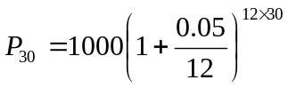

We can quickly calculate 12×30 = 360, giving 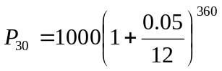.
Now we can use the calculator.

Type this | Calculator shows
0.05 ÷ 12 = . | 0.00416666666667
+ 1 = . | 1.00416666666667
y^{x} 360 = . | 4.46774431400613
× 1000 = . | 4467.74431400613

Using your calculator continued
The previous steps were assuming you have a “one operation at a time” calculator; a more advanced calculator will often allow you to type in the entire expression to be evaluated. If you have a calculator like this, you will probably just need to enter:

1000 × ( 1 + 0.05 ÷ 12 ) y^{x} 360 = .

Annuities
For most of us, we aren’t able to put a large sum of money in the bank today. Instead, we save for the future by depositing a smaller amount of money from each paycheck into the bank. This idea is called a savings annuity. Most retirement plans like 401k plans or IRA plans are examples of savings annuities.

An annuity can be described recursively in a fairly simple way. Recall that basic compound interest follows from the relationship
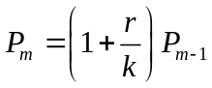

For a savings annuity, we simply need to add a deposit, d, to the account with each compounding period:

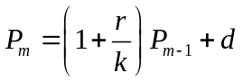

Taking this equation from recursive form to explicit form is a bit trickier than with compound interest. It will be easiest to see by working with an example rather than working in general.

Suppose we will deposit $100 each month into an account paying 6% interest. We assume that the account is compounded with the same frequency as we make deposits unless stated otherwise. In this example:
r = 0.06 (6%)
k = 12 (12 compounds/deposits per year)
d = $100 (our deposit per month)

Writing out the recursive equation gives
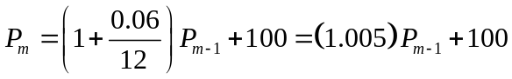

Assuming we start with an empty account, we can begin using this relationship:

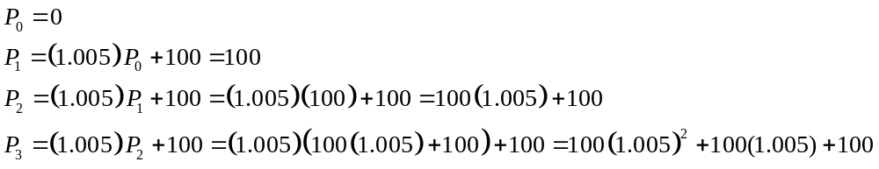

Continuing this pattern, after m deposits, we’d have saved:

In other words, after m months, the first deposit will have earned compound interest for m-1 months. The second deposit will have earned interest for m-2 months. Last months deposit would have earned only one month worth of interest. The most recent deposit will have earned no interest yet.

This equation leaves a lot to be desired, though – it doesn’t make calculating the ending balance any easier! To simplify things, multiply both sides of the equation by 1.005:

Distributing on the right side of the equation gives

Now we’ll line this up with like terms from our original equation, and subtract each side

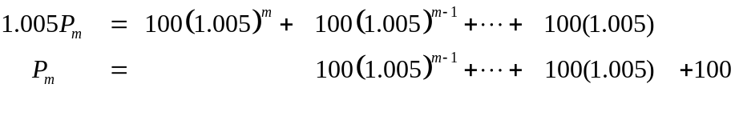
Almost all the terms cancel on the right hand side when we subtract, leaving

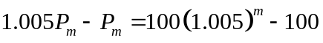

Solving for P_{m}

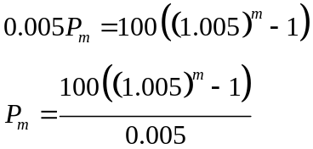

Replacing m months with 12N, where N is measured in years, gives

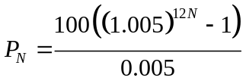

Recall 0.005 was r/k and 100 was the deposit d. 12 was k, the number of deposit each year. Generalizing this result, we get the saving annuity formula.

Annuity Formula
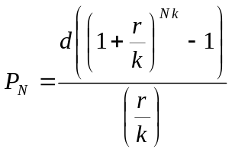

P_{N} is the balance in the account after N years.
d is the regular deposit (the amount you deposit each year, each month, etc.)
r is the annual interest rate in decimal form.
k is the number of compounding periods in one year.

If the compounding frequency is not explicitly stated, assume there are the same number of compounds in a year as there are deposits made in a year.

For example, if the compounding frequency isn’t stated:
If you make your deposits every month, use monthly compounding, k = 12.
If you make your deposits every year, use yearly compounding, k = 1.
If you make your deposits every quarter, use quarterly compounding, k = 4.
Etc.

When do you use this
Annuities assume that you put money in the account on a regular schedule (every month, year, quarter, etc.) and let it sit there earning interest.

Compound interest assumes that you put money in the account once and let it sit there earning interest.

Compound interest: One deposit
Annuity: Many deposits.

Example 7
A traditional individual retirement account (IRA) is a special type of retirement account in which the money you invest is exempt from income taxes until you withdraw it. If you deposit $100 each month into an IRA earning 6% interest, how much will you have in the account after 20 years?

In this example,
d = $100 the monthly deposit
r = 0.06 6% annual rate
k = 12 since we’re doing monthly deposits, we’ll compound monthly
N = 20 we want the amount after 20 years

Putting this into the equation:

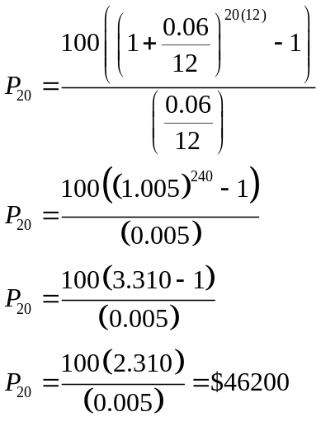

The account will grow to $46,200 after 20 years.

Notice that you deposited into the account a total of $24,000 ($100 a month for 240 months). The difference between what you end up with and how much you put in is the interest earned. In this case it is $46,200 - $24,000 = $22,200.

Example 8
You want to have $200,000 in your account when you retire in 30 years. Your retirement account earns 8% interest. How much do you need to deposit each month to meet your retirement goal?

In this example,
We’re looking for d.
r = 0.08 8% annual rate
k = 12 since we’re depositing monthly
N = 30 30 years
P₃₀ = $200,000 The amount we want to have in 30 years
In this case, we’re going to have to set up the equation, and solve for d.
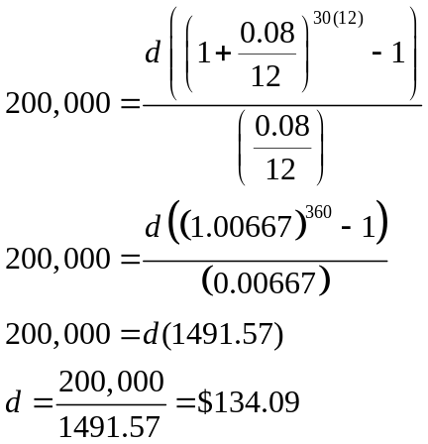

So you would need to deposit $134.09 each month to have $200,000 in 30 years if your account earns 8% interest

Try it Now 2
A more conservative investment account pays 3% interest. If you deposit $5 a day into this account, how much will you have after 10 years? How much is from interest?

Payout Annuities
In the last section you learned about annuities. In an annuity, you start with nothing, put money into an account on a regular basis, and end up with money in your account.

In this section, we will learn about a variation called a Payout Annuity. With a payout annuity, you start with money in the account, and pull money out of the account on a regular basis. Any remaining money in the account earns interest. After a fixed amount of time, the account will end up empty.

Payout annuities are typically used after retirement. Perhaps you have saved $500,000 for retirement, and want to take money out of the account each month to live on. You want the money to last you 20 years. This is a payout annuity. The formula is derived in a similar way as we did for savings annuities. The details are omitted here.

Payout Annuity Formula
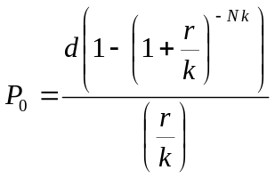

P₀ is the balance in the account at the beginning (starting amount, or principal).
d is the regular withdrawal (the amount you take out each year, each month, etc.)
r is the annual interest rate (in decimal form. Example: 5% = 0.05)
k is the number of compounding periods in one year.
N is the number of years we plan to take withdrawals

Like with annuities, the compounding frequency is not always explicitly given, but is determined by how often you take the withdrawals.

When do you use this
Payout annuities assume that you take money from the account on a regular schedule (every month, year, quarter, etc.) and let the rest sit there earning interest.

Compound interest: One deposit
Annuity: Many deposits.
Payout Annuity: Many withdrawals

Example 9
After retiring, you want to be able to take $1000 every month for a total of 20 years from your retirement account. The account earns 6% interest. How much will you need in your account when you retire?

In this example,
d = $1000 the monthly withdrawal
r = 0.06 6% annual rate
k = 12 since we’re doing monthly withdrawals, we’ll compound monthly
N = 20 since were taking withdrawals for 20 years

We’re looking for P₀; how much money needs to be in the account at the beginning.
Putting this into the equation:

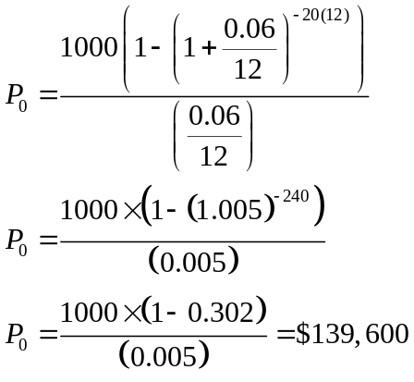

You will need to have $139,600 in your account when you retire.

Notice that you withdrew a total of $240,000 ($1000 a month for 240 months). The difference between what you pulled out and what you started with is the interest earned. In this case it is $240,000 - $139,600 = $100,400 in interest.

Evaluating negative exponents on your calculator
With these problems, you need to raise numbers to negative powers. Most calculators have a separate button for negating a number that is different than the subtraction button. Some calculators label this (-) , some with +/- . The button is often near the = key or the decimal point.

If your calculator displays operations on it (typically a calculator with multiline display), to calculate 1.005⁻²⁴⁰ you'd type something like: 1.005 ^ (-) 240

If your calculator only shows one value at a time, then usually you hit the (-) key after a number to negate it, so you'd hit: 1.005 y^{x} 240 (-) =

Give it a try - you should get 1.005⁻²⁴⁰ = 0.302096

Example 10
You know you will have $500,000 in your account when you retire. You want to be able to take monthly withdrawals from the account for a total of 30 years. Your retirement account earns 8% interest. How much will you be able to withdraw each month?

In this example,
We’re looking for d.
r = 0.08 8% annual rate
k = 12 since we’re withdrawing monthly
N = 30 30 years
P₀ = $500,000 we are beginning with $500,000

In this case, we’re going to have to set up the equation, and solve for d.
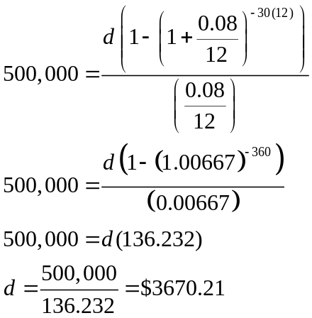

You would be able to withdraw $3,670.21 each month for 30 years.

Try it Now 3
A donor gives $100,000 to a university, and specifies that it is to be used to give annual scholarships for the next 20 years. If the university can earn 4% interest, how much can they give in scholarships each year?

Loans
In the last section, you learned about payout annuities.

In this section, you will learn about conventional loans (also called amortized loans or installment loans). Examples include auto loans and home mortgages. These techniques do not apply to payday loans, add-on loans, or other loan types where the interest is calculated up front.

One great thing about loans is that they use exactly the same formula as a payout annuity. To see why, imagine that you had $10,000 invested at a bank, and started taking out payments while earning interest as part of a payout annuity, and after 5 years your balance was zero. Flip that around, and imagine that you are acting as the bank, and a car lender is acting as you. The car lender invests $10,000 in you. Since you’re acting as the bank, you pay interest. The car lender takes payments until the balance is zero.

Loans Formula

P₀ is the balance in the account at the beginning (the principal, or amount of the loan).
d is your loan payment (your monthly payment, annual payment, etc)
r is the annual interest rate in decimal form.
k is the number of compounding periods in one year.
N is the length of the loan, in years

Like before, the compounding frequency is not always explicitly given, but is determined by how often you make payments.

When do you use this
The loan formula assumes that you make loan payments on a regular schedule (every month, year, quarter, etc.) and are paying interest on the loan.

Compound interest: One deposit
Annuity: Many deposits.
Payout Annuity: Many withdrawals
Loans: Many payments

Example 11
You can afford $200 per month as a car payment. If you can get an auto loan at 3% interest for 60 months (5 years), how expensive of a car can you afford? In other words, what amount loan can you pay off with $200 per month?

In this example,
d = $200 the monthly loan payment
r = 0.03 3% annual rate
k = 12 since we’re doing monthly payments, we’ll compound monthly
N = 5 since we’re making monthly payments for 5 years

We’re looking for P₀, the starting amount of the loan.

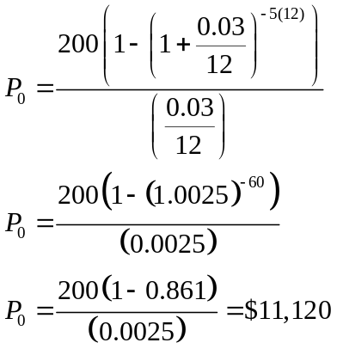

You can afford a $11,120 loan.

You will pay a total of $12,000 ($200 per month for 60 months) to the loan company. The difference between the amount you pay and the amount of the loan is the interest paid. In this case, you’re paying $12,000-$11,120 = $880 interest total.

Example 12
You want to take out a $140,000 mortgage (home loan). The interest rate on the loan is 6%, and the loan is for 30 years. How much will your monthly payments be?

In this example,
We’re looking for d.
r = 0.06 6% annual rate
k = 12 since we’re paying monthly
N = 30 30 years
P₀ = $140,000 the starting loan amount

In this case, we’re going to have to set up the equation, and solve for d.
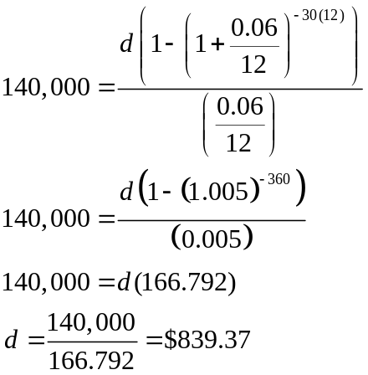

You will make payments of $839.37 per month for 30 years.

You’re paying a total of $302,173.20 to the loan company: $839.37 per month for 360 months. You are paying a total of $302,173.20 - $140,000 = $162,173.20 in interest over the life of the loan.

Try it Now 4
Janine bought $3,000 of new furniture on credit. Because her credit score isn’t very good, the store is charging her a fairly high interest rate on the loan: 16%. If she agreed to pay off the furniture over 2 years, how much will she have to pay each month?

Remaining Loan Balance
With loans, it is often desirable to determine what the remaining loan balance will be after some number of years. For example, if you purchase a home and plan to sell it in five years, you might want to know how much of the loan balance you will have paid off and how much you have to pay from the sale.

To determine the remaining loan balance after some number of years, we first need to know the loan payments, if we don’t already know them. Remember that only a portion of your loan payments go towards the loan balance; a portion is going to go towards interest. For example, if your payments were $1,000 a month, after a year you will not have paid off $12,000 of the loan balance.

To determine the remaining loan balance, we can think “how much loan will these loan payments be able to pay off in the remaining time on the loan?”

Example 13
If a mortgage at a 6% interest rate has payments of $1,000 a month, how much will the loan balance be 10 years from the end the loan?

To determine this, we are looking for the amount of the loan that can be paid off by $1,000 a month payments in 10 years. In other words, we’re looking for P0 when
d = $1,000 the monthly loan payment
r = 0.06 6% annual rate
k = 12 since we’re doing monthly payments, we’ll compound monthly
N = 10 since we’re making monthly payments for 10 more years

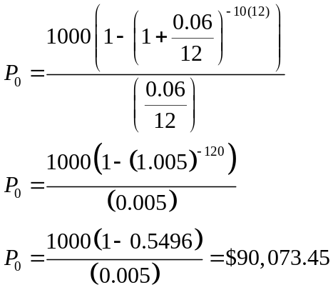

The loan balance with 10 years remaining on the loan will be $90,073.45

Often times answering remaining balance questions requires two steps:
1) Calculating the monthly payments on the loan
2) Calculating the remaining loan balance based on the remaining time on the loan

Example 14
A couple purchases a home with a $180,000 mortgage at 4% for 30 years with monthly payments. What will the remaining balance on their mortgage be after 5 years?

First we will calculate their monthly payments.
We’re looking for d.
r = 0.04 4% annual rate
k = 12 since they’re paying monthly
N = 30 30 years
P₀ = $180,000 the starting loan amount

We set up the equation and solve for d.
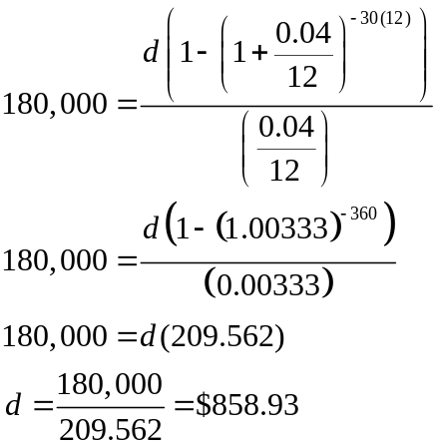

Now that we know the monthly payments, we can determine the remaining balance. We want the remaining balance after 5 years, when 25 years will be remaining on the loan, so we calculate the loan balance that will be paid off with the monthly payments over those 25 years.

d = $858.93 the monthly loan payment we calculated above
r = 0.04 4% annual rate
k = 12 since they’re doing monthly payments
N = 25 since they’d be making monthly payments for 25 more years

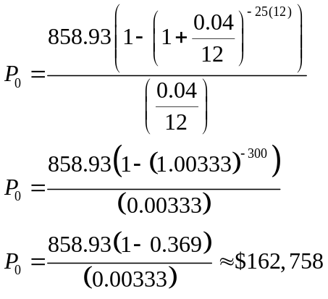

The loan balance after 5 years, with 25 years remaining on the loan, will be $162,758

Over that 5 years, the couple has paid off $180,000 - $162,758 = $17,242 of the loan balance. They have paid a total of $858.93 a month for 5 years (60 months), for a total of $51,535.80, so $51,535.80 - $17,242 = $34,292.80 of what they have paid so far has been interest.

Which equation to use?
When presented with a finance problem (on an exam or in real life), you're usually not told what type of problem it is or which equation to use. Here are some hints on deciding which equation to use based on the wording of the problem.

The easiest types of problem to identify are loans. Loan problems almost always include words like: "loan", "amortize" (the fancy word for loans), "finance (a car)", or "mortgage" (a home loan). Look for these words. If they're there, you're probably looking at a loan problem. To make sure, see if you're given what your monthly (or annual) payment is, or if you're trying to find a monthly payment.

If the problem is not a loan, the next question you want to ask is: "Am I putting money in an account and letting it sit, or am I making regular (monthly/annually/quarterly) payments or withdrawals?" If you're letting the money sit in the account with nothing but interest changing the balance, then you're looking at a compound interest problem. The exception would be bonds and other investments where the interest is not reinvested; in those cases you’re looking at simple interest.
If you're making regular payments or withdrawals, the next questions is: "Am I putting money into the account, or am I pulling money out?" If you're putting money into the account on a regular basis (monthly/annually/quarterly) then you're looking at a basic Annuity problem. Basic annuities are when you are saving money. Usually in an annuity problem, your account starts empty, and has money in the future.
If you're pulling money out of the account on a regular basis, then you're looking at a Payout Annuity problem. Payout annuities are used for things like retirement income, where you start with money in your account, pull money out on a regular basis, and your account ends up empty in the future.

Remember, the most important part of answering any kind of question, money or otherwise, is first to correctly identify what the question is really asking, and to determine what approach will best allow you to solve the problem.

Try it Now 5
For each of the following scenarios, determine if it is a compound interest problem, a savings annuity problem, a payout annuity problem, or a loans problem. Then solve each problem.

- Marcy received an inheritance of $20,000, and invested it at 6% interest. She is going to use it for college, withdrawing money for tuition and expenses each quarter. How much can she take out each quarter if she has 3 years of school left?
- Paul wants to buy a new car. Rather than take out a loan, he decides to save $200 a month in an account earning 3% interest compounded monthly. How much will he have saved up after 3 years?
- Keisha is managing investments for a non-profit company. They want to invest some money in an account earning 5% interest compounded annually with the goal to have $30,000 in the account in 6 years. How much should Keisha deposit into the account?
- Miao is going to finance new office equipment at a 2% rate over a 4 year term. If she can afford monthly payments of $100, how much new equipment can she buy?
- How much would you need to save every month in an account earning 4% interest to have $5,000 saved up in two years?

Solving for time
Often we are interested in how long it will take to accumulate money or how long we’d need to extend a loan to bring payments down to a reasonable level.

Note: This section assumes you’ve covered solving exponential equations using logarithms, either in prior classes or in the growth models chapter.

Example 15
If you invest $2000 at 6% compounded monthly, how long will it take the account to double in value?

This is a compound interest problem, since we are depositing money once and allowing it to grow. In this problem,
P₀ = $2000 the initial deposit
r = 0.06 6% annual rate
k = 12 12 months in 1 year

So our general equation is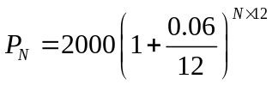. We also know that we want our ending amount to be double of $2000, which is $4000, so we’re looking for N so that P_{N} = 4000. To solve this, we set our equation for P_{N} equal to 4000.

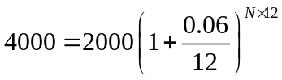 Divide both sides by 2000
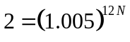 To solve for the exponent, take the log of both sides
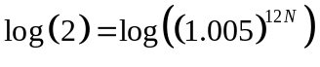 Use the exponent property of logs on the right side
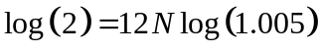 Now we can divide both sides by 12log(1.005)
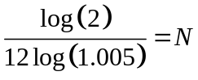 Approximating this to a decimal

N = 11.581

It will take about 11.581 years for the account to double in value. Note that your answer may come out slightly differently if you had evaluated the logs to decimals and rounded during your calculations, but your answer should be close. For example if you rounded log(2) to 0.301 and log(1.005) to 0.00217, then your final answer would have been about 11.577 years.

Example 16
If you invest $100 each month into an account earning 3% compounded monthly, how long will it take the account to grow to $10,000?

This is a savings annuity problem since we are making regular deposits into the account.
d = $100 the monthly deposit
r = 0.03 3% annual rate
k = 12 since we’re doing monthly deposits, we’ll compound monthly
We don’t know N, but we want P_{N} to be $10,000.

Putting this into the equation:

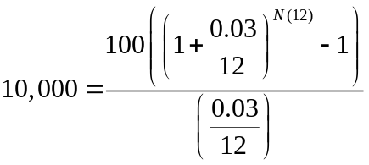 Simplifying the fractions a bit
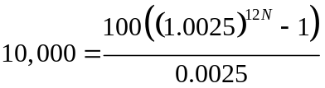

We want to isolate the exponential term, 1.0025^{12N}, so multiply both sides by 0.0025

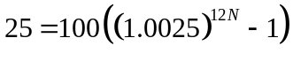 Divide both sides by 100
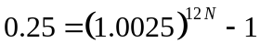 Add 1 to both sides
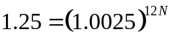 Now take the log of both sides
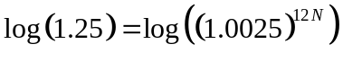 Use the exponent property of logs
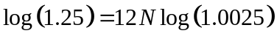 Divide by 12log(1.0025)
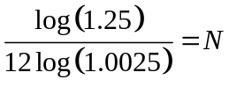 Approximating to a decimal

N = 7.447 years

It will take about 7.447 years to grow the account to $10,000.

Try it Now 6
Joel is considering putting a $1,000 laptop purchase on his credit card, which has an interest rate of 12% compounded monthly. How long will it take him to pay off the purchase if he makes payments of $30 a month?

Try it Now Answers
1.
I = $30 of interest
P₀ = $500 principal
r = unknown
t = 1 month

Using I = P₀rt, we get 30 = 500·r·1. Solving, we get r = 0.06, or 6%. Since the time was monthly, this is the monthly interest. The annual rate would be 12 times this: 72% interest.

2.
d = $5 the daily deposit
r = 0.03 3% annual rate
k = 365 since we’re doing daily deposits, we’ll compound daily
N = 10 we want the amount after 10 years
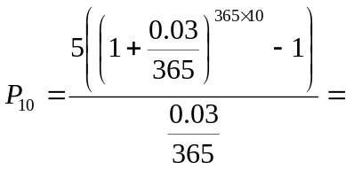$21,282.07
We would have deposited a total of $5·365·10 = $18,250, so $3,032.07 is from interest

3.
d = unknown
r = 0.04 4% annual rate
k = 1 since we’re doing annual scholarships
N = 20 20 years
P₀ = 100,000 we’re starting with $100,000
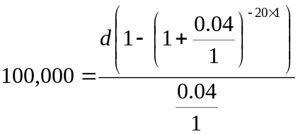

Solving for d gives $7,358.18 each year that they can give in scholarships.

It is worth noting that usually donors instead specify that only interest is to be used for scholarship, which makes the original donation last indefinitely. If this donor had specified that, $100,000(0.04) = $4,000 a year would have been available.

Try it Now Answers continued
4.
d = unknown
r = 0.16 16% annual rate
k = 12 since we’re making monthly payments
N = 2 2 years to repay
P₀ = 3,000 we’re starting with a $3,000 loan
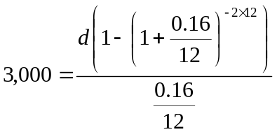

Solving for d gives $146.89 as monthly payments.

In total, she will pay $3,525.36 to the store, meaning she will pay $525.36 in interest over the two years.

5.
- This is a payout annuity problem. She can pull out $1833.60 a quarter.
- This is a savings annuity problem. He will have saved up $7,524.11/
- This is compound interest problem. She would need to deposit $22,386.46.
- This is a loans problem. She can buy $4,609.33 of new equipment.
- This is a savings annuity problem. You would need to save $200.46 each month

6.
d = $30 The monthly payments
r = 0.12 12% annual rate
k = 12 since we’re making monthly payments
P₀ = 1,000 we’re starting with a $1,000 loan
We are solving for N, the time to pay off the loan
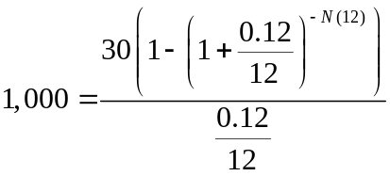

Solving for N gives 3.396. It will take about 3.4 years to pay off the purchase.

Exercises

Skills
- A friend lends you $200 for a week, which you agree to repay with 5% one-time interest. How much will you have to repay?

- Suppose you obtain a $3,000 T-note with a 3% annual rate, paid quarterly, with maturity in 5 years. How much interest will you earn?

- A T-bill is a type of bond that is sold at a discount over the face value. For example, suppose you buy a 13-week T-bill with a face value of $10,000 for $9,800. This means that in 13 weeks, the government will give you the face value, earning you $200. What annual interest rate have you earned?

- Suppose you are looking to buy a $5000 face value 26-week T-bill. If you want to earn at least 1% annual interest, what is the most you should pay for the T-bill?

- You deposit $300 in an account earning 5% interest compounded annually. How much will you have in the account in 10 years?

- How much will $1000 deposited in an account earning 7% interest compounded annually be worth in 20 years?

- You deposit $2000 in an account earning 3% interest compounded monthly.
  - How much will you have in the account in 20 years?
  - How much interest will you earn?

- You deposit $10,000 in an account earning 4% interest compounded monthly.
  - How much will you have in the account in 25 years?
  - How much interest will you earn?

- How much would you need to deposit in an account now in order to have $6,000 in the account in 8 years? Assume the account earns 6% interest compounded monthly.

- How much would you need to deposit in an account now in order to have $20,000 in the account in 4 years? Assume the account earns 5% interest.

- You deposit $200 each month into an account earning 3% interest compounded monthly.
  - How much will you have in the account in 30 years?
  - How much total money will you put into the account?
  - How much total interest will you earn?

- You deposit $1000 each year into an account earning 8% compounded annually.
  - How much will you have in the account in 10 years?
  - How much total money will you put into the account?
  - How much total interest will you earn?

- Jose has determined he needs to have $800,000 for retirement in 30 years. His account earns 6% interest.
  - How much would he need to deposit in the account each month?
  - How much total money will he put into the account?
  - How much total interest will he earn?

- You wish to have $3000 in 2 years to buy a fancy new stereo system. How much should you deposit each quarter into an account paying 8% compounded quarterly?

- You want to be able to withdraw $30,000 each year for 25 years. Your account earns 8% interest.
  - How much do you need in your account at the beginning
  - How much total money will you pull out of the account?
  - How much of that money is interest?

- How much money will I need to have at retirement so I can withdraw $60,000 a year for 20 years from an account earning 8% compounded annually?
  - How much do you need in your account at the beginning
  - How much total money will you pull out of the account?
  - How much of that money is interest?

- You have $500,000 saved for retirement. Your account earns 6% interest. How much will you be able to pull out each month, if you want to be able to take withdrawals for 20 years?

- Loren already knows that he will have $500,000 when he retires. If he sets up a payout annuity for 30 years in an account paying 10% interest, how much could the annuity provide each month?

- You can afford a $700 per month mortgage payment. You’ve found a 30 year loan at 5% interest.
  - How big of a loan can you afford?
  - How much total money will you pay the loan company?
  - How much of that money is interest?

- Marie can afford a $250 per month car payment. She’s found a 5 year loan at 7% interest.
  - How expensive of a car can she afford?
  - How much total money will she pay the loan company?
  - How much of that money is interest?

- You want to buy a $25,000 car. The company is offering a 2% interest rate for 48 months (4 years). What will your monthly payments be?

- You decide finance a $12,000 car at 3% compounded monthly for 4 years. What will your monthly payments be? How much interest will you pay over the life of the loan?

- You want to buy a $200,000 home. You plan to pay 10% as a down payment, and take out a 30 year loan for the rest.
  - How much is the loan amount going to be?
  - What will your monthly payments be if the interest rate is 5%?
  - What will your monthly payments be if the interest rate is 6%?

- Lynn bought a $300,000 house, paying 10% down, and financing the rest at 6% interest for 30 years.
  - Find her monthly payments.
  - How much interest will she pay over the life of the loan?

- Emile bought a car for $24,000 three years ago. The loan had a 5 year term at 3% interest rate, making monthly payments. How much does he still owe on the car?

- A friend bought a house 15 years ago, taking out a $120,000 mortgage at 6% for 30 years, making monthly payments. How much does she still owe on the mortgage?

- Pat deposits $6,000 into an account earning 4% compounded monthly. How long will it take the account to grow to $10,000?

- Kay is saving $200 a month into an account earning 5% interest. How long will it take her to save $20,000?

- James has $3,000 in credit card debt, which charges 14% interest. How long will it take to pay off the card if he makes the minimum payment of $60 a month?

- Chris has saved $200,000 for retirement, and it is in an account earning 6% interest. If she withdraws $3,000 a month, how long will the money last?

Concepts
- Suppose you invest $50 a month for 5 years into an account earning 8% compounded monthly. After 5 years, you leave the money, without making additional deposits, in the account for another 25 years. How much will you have in the end?

- Suppose you put off making investments for the first 5 years, and instead made deposits of $50 a month for 25 years into an account earning 8% compounded monthly. How much will you have in the end?

- Mike plans to make contributions to his retirement account for 15 years. After the last contribution, he will start withdrawing $10,000 a quarter for 10 years. Assuming Mike's account earns 8% compounded quarterly, how large must his quarterly contributions be during the first 15 years, in order to accomplish his goal?

- Kendra wants to be able to make withdrawals of $60,000 a year for 30 years after retiring in 35 years. How much will she have to save each year up until retirement if her account earns 7% interest?
- You have $2,000 to invest, and want it to grow to $3,000 in two years. What interest rate would you need to find to make this possible?

- You have $5,000 to invest, and want it to grow to $20,000 in ten years. What interest rate would you need to find to make this possible?

- You plan to save $600 a month for the next 30 years for retirement. What interest rate would you need to have $1,000,000 at retirement?

- You really want to buy a used car for $11,000, but can only afford $200 a month. What interest rate would you need to find to be able to afford the car, assuming the loan is for 60 months?

Exploration
- Pay day loans are short term loans that you take out against future paychecks: The company advances you money against a future paycheck. Either visit a pay day loan company, or look one up online. Be forewarned that many companies do not make their fees obvious, so you might need to do some digging or look at several companies.
  - Explain the general method by which the loan works.
  - We will assume that we need to borrow $500 and that we will pay back the loan in 14 days. Determine the total amount that you would need to pay back and the effective loan rate. The effective loan rate is the percentage of the original loan amount that you pay back. It is not the same as the APR (annual rate) that is probably published.
  - If you cannot pay back the loan after 14 days, you will need to get an extension for another 14 days. Determine the fees for an extension, determine the total amount you will be paying for the now 28 day loan, and compute the effective loan rate.

- Suppose that 10 years ago you bought a home for $110,000, paying 10% as a down payment, and financing the rest at 9% interest for 30 years.
  - Let's consider your existing mortgage:
    - How much money did you pay as your down payment?
    - How much money was your mortgage (loan) for?
    - What is your current monthly payment?
    - How much total interest will you pay over the life of the loan?
  - This year, you check your loan balance. Only part of your payments have been going to pay down the loan; the rest has been going towards interest. You see that you still have $88,536 left to pay on your loan. Your house is now valued at $150,000.
    - How much of the loan have you paid off? (i.e., how much have you reduced the loan balance by? Keep in mind that interest is charged each month - it's not part of the loan balance.)
    - How much money have you paid to the loan company so far?
    - How much interest have you paid so far?
    - How much equity do you have in your home (equity is value minus remaining debt)
  - Since interest rates have dropped, you consider refinancing your mortgage at a lower 6% rate.
    - If you took out a new 30 year mortgage at 6% for your remaining loan balance, what would your new monthly payments be?
    - How much interest will you pay over the life of the new loan?
  - Notice that if you refinance, you are going to be making payments on your home for another 30 years. In addition to the 10 years you've already been paying, that's 40 years total.
    - How much will you save each month because of the lower monthly payment?
    - How much total interest will you be paying (you need to consider the amount from 2c and 3b)
    - Does it make sense to refinance? (there isn't a correct answer to this question. Just give your opinion and your reason)

